**Object-Oriented Programming**

**Lab Session #3**

**I. References**

- Oracle Java Documentation: https://docs.oracle.com/javase/tutorial/java/IandI/index.html

- Inheritance in Java Tutorial: https://www.tutorialspoint.com/java/java_inheritance.htm

**II. Exercises**

You are required to implement the following design as well as a main() method in a another class to test your implementation:

1. Shapes (25 points)

Implement the hierarchy below where

* MyShape is an class with a Draw method that does nothing,
* MyBoundedShape is a class with a GetArea method that does nothing,
* MyLine, MyOval, MyRectangle are classes

In the main() method,

* Ask user to select 5 shapes and input their dimension
* Draw selected shapes
* Compute and show area of selected shapes if they are a bounded shape

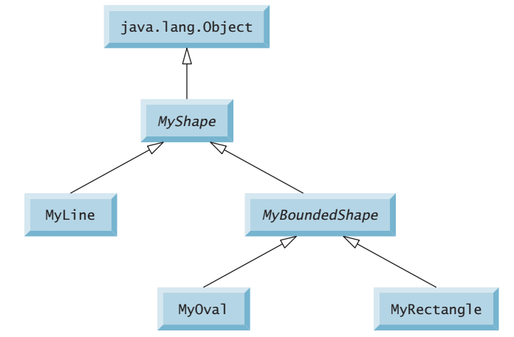

**MyShape.java:**

package Lab3.Question1;

public class MyShape {

    public MyShape(){

    }

    public void Draw(){

    }

}

**MyLine.java:**

package Lab3.Question1;

public class MyLine extends MyShape {

    private int length;

    public MyLine(int length){

        this.length = length;

    }

    public int getLength() {

        return length;

    }

    public void setLength(int length) {

        this.length = length;

    }

    @Override

    public void Draw(){

        for (int i = 0; i < length; i++) {

            System.out.print("*");

        }

    }

}

**MyBoundedShape.java:**

package Lab3.Question1;

public class MyBoundedShape extends MyShape {

    public MyBoundedShape(){

    }

    public double getArea(){

        return 0;

    }

}

**MyOval.java:**

package Lab3.Question1;

import java.lang.Math;

public class MyOval extends MyBoundedShape{

    private int height;

    private int width;

    public MyOval(int height, int width) {

        this.height = height;

        this.width = width;

    }

    public int getHeight() {

        return height;

    }

    public void setHeight(int height) {

        this.height = height;

    }

    public int getWidth() {

        return width;

    }

    public void setWidth(int width) {

        this.width = width;

    }

    @Override

    public double getArea(){

        return Math.PI * (height/2) * (width/2);

    }

    @Override

    public void Draw() {

        for (int i = 0; i < height; i++) {

            for (int j = 0; j < width; j++) {

                if (Math.pow((i - height/2), 2)/Math.pow((height/2), 2) + Math.pow((j - width/2), 2)/Math.pow((width/2), 2) <= 1) {

                    System.out.print("*");

                } else {

                    System.out.print(" ");

                }

            }

            System.out.println();

        }

    }

}

**MyRectangle.java:**

package Lab3.Question1;

public class MyRectangle extends MyBoundedShape{

    private int height;

    private int width;

    public MyRectangle(int height, int width){

        this.height = height;

        this.width = width;

    }

    public int getHeight() {

        return height;

    }

    public void setHeight(int height) {

        this.height = height;

    }

    public int getWidth() {

        return width;

    }

    public void setWidth(int width) {

        this.width = width;

    }

    @Override

    public void Draw(){

        for (int i = 0; i < height; i++) {

            for (int j = 0; j < width; j++) {

                System.out.print("*");

            }

            System.out.println();

        }

    }

    @Override

    public double getArea(){

        return height * width;

    }

}

**Test.java:**

package Lab3.Question1;

import java.util.Scanner;

public class Test {

    public static void main(String[] args) {

        MyShape[] shapes = new MyShape[5];

        Scanner input = new Scanner(System.in);

        for (int i=0;i<5;i++){

            System.out.println("Select a shape "+(i+1)+" to draw (Line: 1, Oval: 2, Rectangle: 3): ");

            int shape = input.nextInt();

            if (shape==1){

                System.out.println("Enter the length of the line: ");

                int length = input.nextInt();

                shapes[i] = new MyLine(length);

            }

            else if (shape==2){

                System.out.println("Enter the height of the oval: ");

                int height = input.nextInt();

                System.out.println("Enter the width of the oval: ");

                int width = input.nextInt();

                shapes[i] = new MyOval(height, width);

            }

            else if (shape==3){

                System.out.println("Enter the height of the rectangle: ");

                int height = input.nextInt();

                System.out.println("Enter the width of the rectangle: ");

                int width = input.nextInt();

                shapes[i] = new MyRectangle(height, width);

            }

            else{

                System.out.println("Invalid shape");

            }

        }

        System.out.println();

        for (int i=0;i<5;i++) {

            if (shapes[i] instanceof MyOval){

                System.out.println("The shape "+(i+1)+" is Oval with height " + ((MyOval)shapes[i]).getHeight()+ " and width " + ((MyOval)shapes[i]).getWidth());

            }

            if (shapes[i] instanceof MyRectangle){

                System.out.println("The shape "+(i+1)+" is Rectangle with height " + ((MyRectangle)shapes[i]).getHeight()+ " and width " + ((MyRectangle)shapes[i]).getWidth());

            }

            if (shapes[i] instanceof MyLine){

                System.out.println("The shape "+(i+1)+" is Line with length " + ((MyLine)shapes[i]).getLength());

            }

            if (shapes[i] instanceof MyBoundedShape) {

                System.out.println("Area: " + ((MyBoundedShape)shapes[i]).getArea());

            }

            System.out.println("Drawing the shape "+(i+1)+" :");

            shapes[i].Draw();

            System.out.println();

        }

    }

}

**Output:**

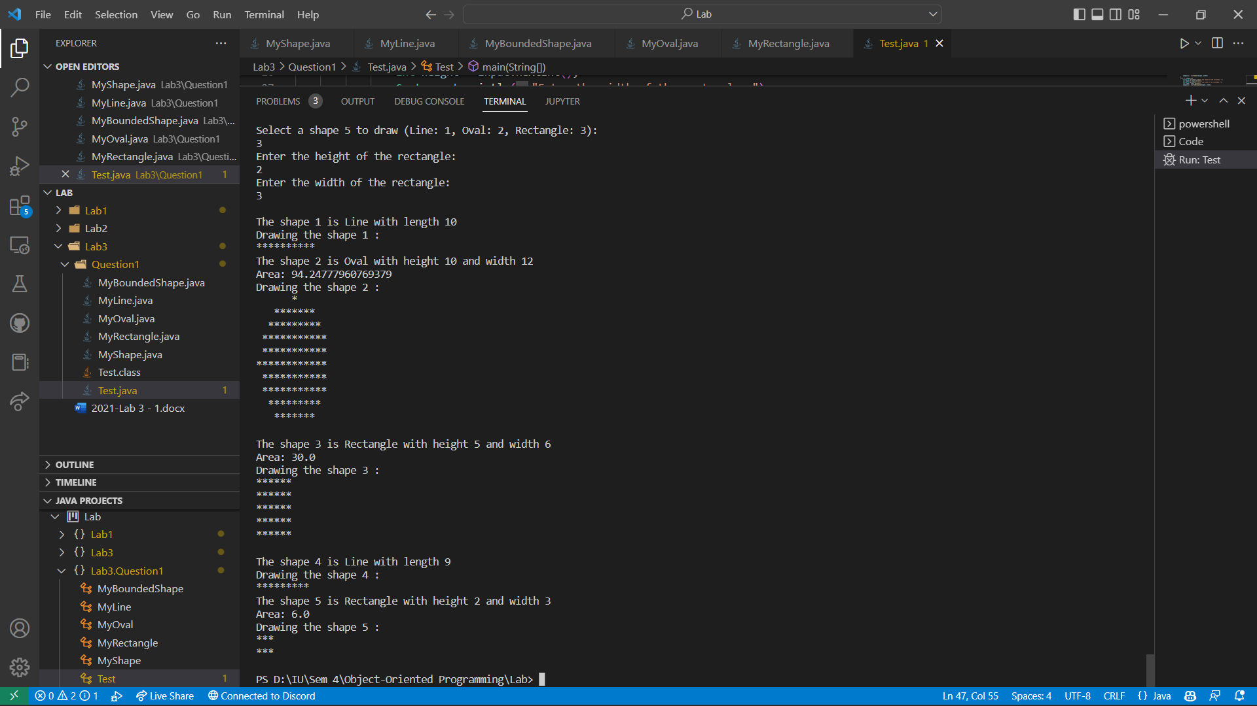

1. Triangle and Point (25 points)

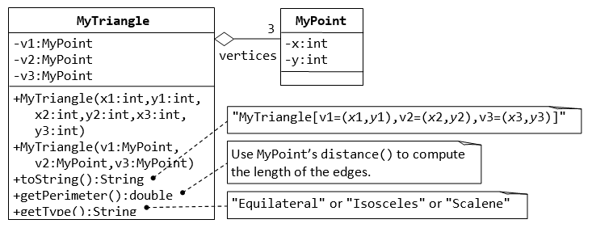

**MyPoint.java:**

package Lab3.Question2;

import java.lang.Math;

public class MyPoint {

    private int x;

    private int y;

    public MyPoint() {

        this.x = 0;

        this.y = 0;

    }

    public MyPoint(int x, int y) {

        this.x = x;

        this.y = y;

    }

    public int getX() {

        return x;

    }

    public void setX(int x) {

        this.x = x;

    }

    public int getY() {

        return y;

    }

    public void setY(int y) {

        this.y = y;

    }

    public double distance(int x, int y) {

        return Math.sqrt(Math.pow(this.x - x, 2) + Math.pow(this.y - y, 2));

    }

}

**MyTriangle.java:**

package Lab3.Question2;

public class MyTriangle{

    private MyPoint v1;

    private MyPoint v2;

    private MyPoint v3;

    public MyTriangle(int x1, int y1, int x2, int y2, int x3, int y3) {

        this.v1 = new MyPoint(x1, y1);

        this.v2 = new MyPoint(x2, y2);

        this.v3 = new MyPoint(x3, y3);

    }

    public MyTriangle(MyPoint v1, MyPoint v2, MyPoint v3) {

        this.v1 = v1;

        this.v2 = v2;

        this.v3 = v3;

    }

    public String toString(){

        return "My Triangle [v1=(" + v1.getX()+","+v1.getY() + "), v2=(" + v2.getX()+","+v2.getY() + "), v3=(" + v3.getX()+","+v3.getY() + ")]";

    }

    public double getPerimeter(){

        return v1.distance(v2.getX(), v2.getY()) + v2.distance(v3.getX(), v3.getY()) + v3.distance(v1.getX(), v1.getY());

    }

    public String getType(){

        double side1 = v1.distance(v2.getX(), v2.getY());

        double side2 = v2.distance(v3.getX(), v3.getY());

        double side3 = v3.distance(v1.getX(), v1.getY());

        if (side1 == side2 && side2 == side3){

            return "Equilateral";

        } else if (side1 == side2 || side2 == side3 || side3 == side1){

            return "Isosceles";

        } else {

            return "Scalene";

        }

    }

}

**Test.java:**

package Lab3.Question2;

public class Test {

    public static void main(String[] args) {

        MyTriangle[] triangles = new MyTriangle[3];

        MyPoint p1 = new MyPoint(2, 0);

        MyPoint p2 = new MyPoint(2, 4);

        MyPoint p3 = new MyPoint(6, 4);

        triangles[0] = new MyTriangle(0, 0, 2, 4, 4, 4);

        triangles[1] = new MyTriangle(p1, p2, p3);

        triangles[2] = new MyTriangle(-4, 0, 0, 4, 6, 4);

        for (int i=0;i<3;i++) {

            System.out.println(triangles[i].toString());

            System.out.println("Triangle "+(i+1)+" has perimeter "+triangles[i].getPerimeter());

            System.out.println("Triangle "+(i+1)+" is "+triangles[i].getType());

            System.out.println();

        }

    }

}

**Output:**

1. Person, Student & Staff (25 points)

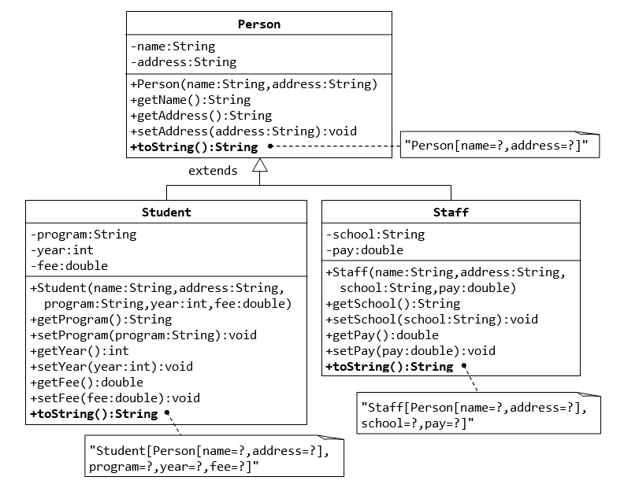

**Person.java:**

package Lab3.Question3;

public class Person {

    private String name;

    private String address;

    public Person(String name, String address) {

        this.name = name;

        this.address = address;

    }

    void setName(String name) {

        this.name = name;

    }

    void setAddress(String address) {

        this.address = address;

    }

    public String getName() {

        return name;

    }

    public String getAddress() {

        return address;

    }

    public String toString() {

        return "Person[name=" + name + ",address=" + address + "]";

    }

}

**Staff.java:**

package Lab3.Question3;

public class Staff extends Person{

    private String school;

    private double pay;

    public Staff(String name, String address, String school, double pay) {

        super(name, address);

        this.school = school;

        this.pay = pay;

    }

    void setSchool(String school) {

        this.school = school;

    }

    void setPay(double pay) {

        this.pay = pay;

    }

    public String getSchool() {

        return school;

    }

    public double getPay() {

        return pay;

    }

    public String toString() {

        return "Staff[" + super.toString() + ",school=" + school + ",pay=" + pay + "]";

    }

}

**Student.java:**

package Lab3.Question3;

public class Student extends Person{

    private String program;

    private int year;

    private double fee;

    public Student(String name, String address, String program, int year, double fee) {

        super(name, address);

        this.program = program;

        this.year = year;

        this.fee = fee;

    }

    void setProgram(String program) {

        this.program = program;

    }

    void setYear(int year) {

        this.year = year;

    }

    void setFee(double fee) {

        this.fee = fee;

    }

    public String getProgram() {

        return program;

    }

    public int getYear() {

        return year;

    }

    public double getFee() {

        return fee;

    }

    public String toString() {

        return "Student[" + super.toString() + ",program=" + program + ",year=" + year + ",fee=" + fee + "]";

    }

}

**Test.java:**

package Lab3.Question3;

public class Test {

    public static void main(String[] args) {

        Person p1 = new Person("John", "123 Main St");

        System.out.println(p1);

        Student s1 = new Student("Mary", "456 Main St", "Computer Science", 2019, 10000);

        System.out.println(s1);

        Staff st1 = new Staff("Bob", "789 Main St", "Computer Science", 10000);

        System.out.println(st1);

    }

}

**Output:**

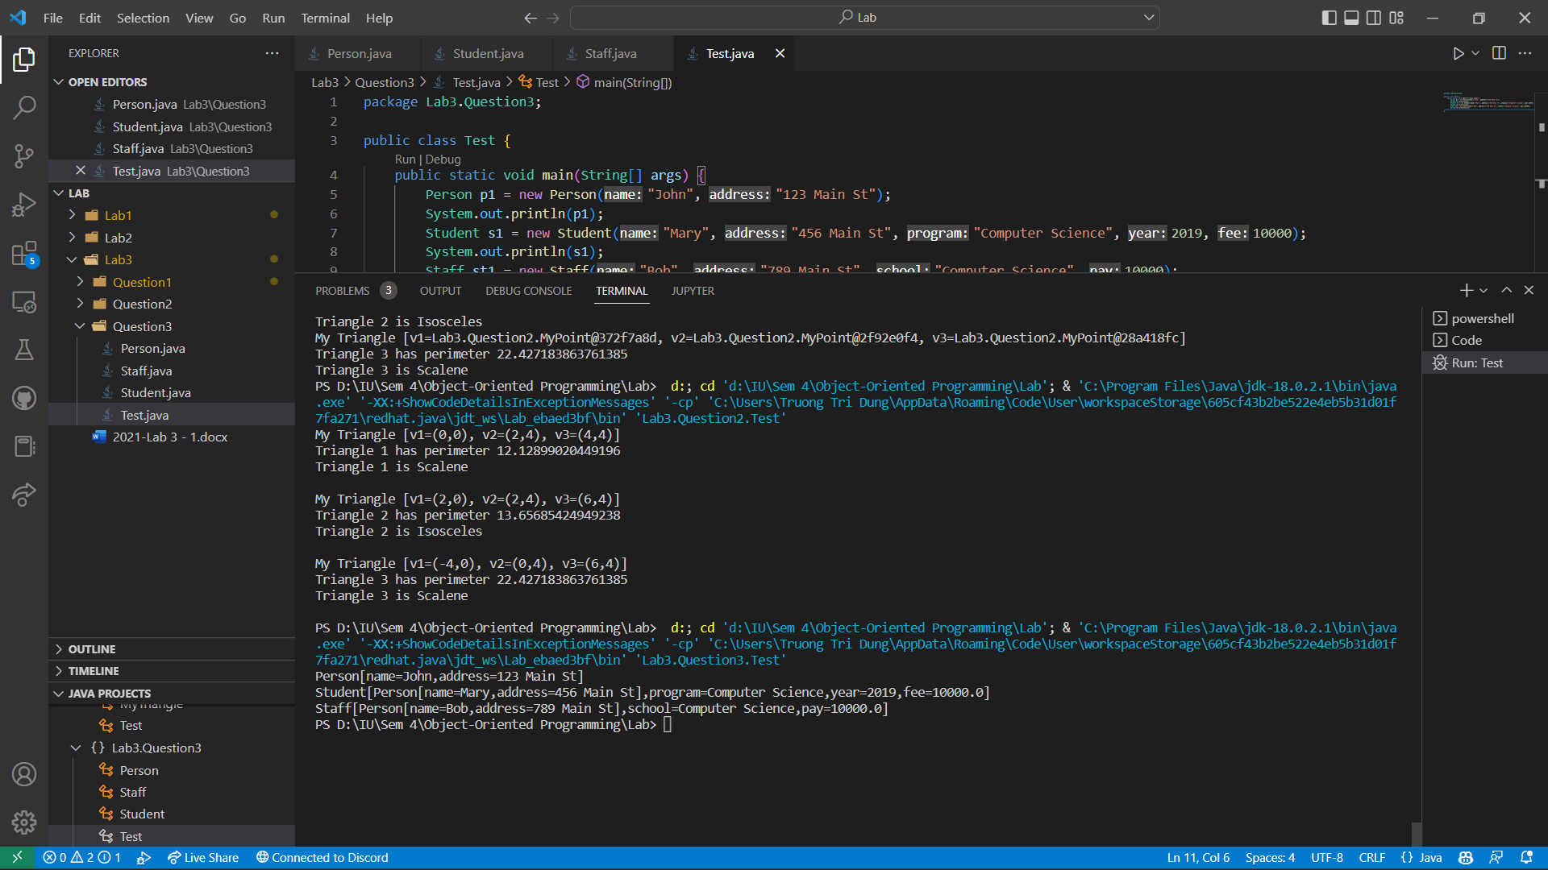

1. Point2D and Point3D (25 points)

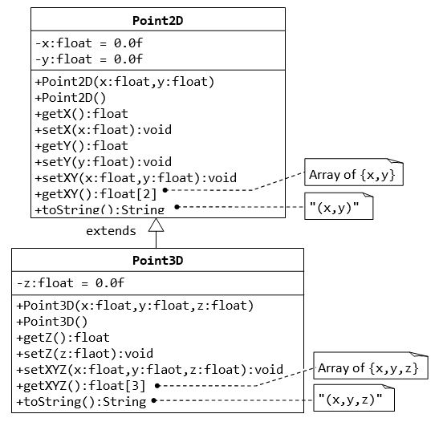

**Point2D.java:**

package Lab3.Question4;

public class Point2D {

    private float x;

    private float y;

    public Point2D(float x, float y) {

        this.x = x;

        this.y = y;

    }

    public Point2D() {

        this(0, 0);

    }

    public float getX() {

        return x;

    }

    public float getY() {

        return y;

    }

    public void setX(float x) {

        this.x = x;

    }

    public void setY(float y) {

        this.y = y;

    }

    public void setXY(float x, float y) {

        this.x = x;

        this.y = y;

    }

    public float[] getXY() {

        return new float[] {x, y};

    }

    public String toString() {

        return "(" + x + ", " + y + ")";

    }

}

**Point3D.java:**

package Lab3.Question4;

public class Point3D extends Point2D {

    private float z;

    public Point3D(float x, float y, float z) {

        super(x, y);

        this.z = z;

    }

    public Point3D() {

        this(0, 0, 0);

    }

    void setZ(float z) {

        this.z = z;

    }

    float getZ() {

        return z;

    }

    void setXYZ(float x, float y, float z) {

        super.setXY(x, y);

        this.z = z;

    }

    float[] getXYZ() {

        return new float[] {super.getX(), super.getY(), z};

    }

    public String toString() {

        return "(" + super.getX() + ", " + super.getY() + ", " + z + ")";

    }

}

**Test.java:**

package Lab3.Question4;

public class Test {

    public static void main(String[] args) {

        Point3D p1 = new Point3D(1, 2, 3);

        System.out.println(p1);

        Point3D p2 = new Point3D();

        System.out.println(p2);

        Point2D p3 = new Point2D(2,4);

        System.out.println(p3);

    }

}

**Output:**

